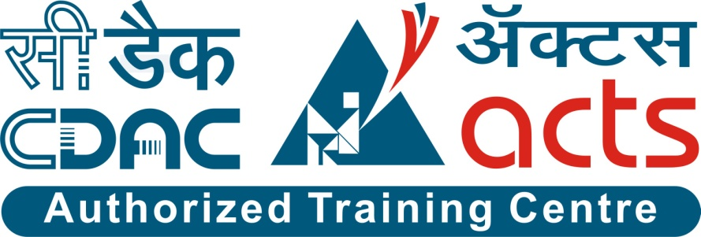

Project Name: LifeStream Blood Bank Management System

Branch PG-DAC Mar-2023

Documentation On

**“LifeStream Blood Bank Management System”**

PG-DAC SEPT 2022

**Guided By: Dipali**

Submitted By :

**Group No: 02**

* **Atharva Pawar 230343020007**
* **Rushikesh Mohite 200943020077**
* **Tanmay Purohit 230343020098**
* **Shreenand Wadgaonkar 230343020109**

**Table of Contents**

**1. Introduction 4**

1.1 Document Purpose **4**

1.2 Project Background **4**

1.3 Aim & Objectives **4**

**2. Business Requirements Overview**…………………………………………………………**5**

**3.Functional Requirements** **6**

3.1 Admin Module **6**

3.2 Receiver Module **6**

3.3 Donor Module **7**

**4.** **Non-Functional Requirement………………………………………………………………7**

**5. Use Case Diagram 8**

5.1 Admin **8**

5.2 Receiver **9**

5.3 Donor **10**

**6. Database Design 11**

1 Login **11**

2 Roles **11**

3 Request…………………………………………………………………………………… **11**

4 Donor History **12**

5 Stock **12**

6 Camps **12**

7 Payments **13**

**7. E-R Diagram………………………………………………………………………………………14**

**8. Snapshots 15**

**9. Conclusion 22**

**List of Figures**

**Use Case Diagrams 17**

Fig 1 Admin 8

Fig 2 Receiver 9

Fig 3 Donor 10

Fig 4 ER Diagram 14

1. **Introduction:**
   1. **Document Purpose:**

The focus of this system is to provide an online easy access to blood stock and manage blood stock data available, so that using this blood bank management system people can search blood group available they need. It will replace the paperwork. It keeps records of donor, buyer, and blood stock. This system helps the customer to enquire the availability of blood they need. Second module helps him to make a payment and reserve a ticket. • First module helps donors and buyers to access the system by simple registration • Second module will be accessed by Admin to manage the stock details and organization details.

## Project Background:

The main aim of developing this system to provide blood to the people who are increasing in large number day by day. This blood bank management system is an online website, so it is easily available to everyone. When person want to donate blood, he/she must register to the system. Donor registration is very easy. Admin will manage the blood stock and organization details for blood donation campaigns. When person want to buy the blood bag, he/she can register to the system to check availability of blood stock to buy a blood bag

## Aim & Objectives:

Specific goals are: -

• To produce a web-based system that allows the admin to manage the blood stock.

• To ease donor/buyer the process of buying or donating the blood.

1. **Business Requirements Overview:**

# 1. Donor Registration:

# - The system allows individuals who wish to donate blood to easily register themselves.

# - The registration process is user-friendly and straightforward, enabling potential donors to provide their necessary details and contact information.

# - Upon successful registration, donors become part of the system and can contribute to the blood stock.

# 2. Admin Management:

# - The system provides an administrative interface for authorized personnel to manage the blood stock and organizational details for blood donation campaigns.

# - Admins can add, update, and delete information related to blood types, available blood units, expiration dates, and other relevant details.

# - They can also manage the details of upcoming blood donation campaigns, including location, date, and time.

# 3. Blood Stock Management:

# - The system keeps track of the available blood stock, providing real-time information on the quantity and type of blood units.

# - Admins can monitor the stock levels, ensuring an adequate supply of different blood types based on demand and expiry dates.

# - The system generates alerts or notifications for low stock levels or nearing expiration dates to prompt necessary actions, such as organizing blood drives or discarding expired units.

# 4. Blood Bag Purchase:

# - Individuals in need of blood can register with the system to check the availability of blood stock and purchase blood bags if required.

# - Registered users can search for specific blood types and view the current stock levels to make informed decisions.

# - The system facilitates the purchase process, including payment options and delivery details, ensuring a seamless experience for the buyers.

# Functional Requirements Overview:

# 1)Admin: -Manage the Registration of users, donors, and organization.

# -View User/Donor and organization information.

# 2)User: - Register.

# -Login.

# - Check the blood availability.

# -Post the blood request.

# 3)Donor: -Register

# -login

# -Book an appointment to donate blood.

# 4) organization: -registration

# -login

# -Schedule the blood donation campaign.

# 3.1 User Module

* User can create, delete and modify his own account.
* LifeStream provides the users to buy the blood which is required through online mode.
* He is able to browse existing through availability of blood.
* User will make payment to BloodBank.

# 3.2 Donor Module

* Donor can register and create his own account.
* LifeStream provides the function which allows the donors to schedule the blood donation appointments.
* Donors can also Track their blood donation history to keep a record.

# 3.3 Admin Module

* LifeStream System should provide all function to admin how to handle the System.
* Admin should be able to keep the track of the blood Stock.
* Admin also should be able to manage the blood donation camps organized.

1. **Non-Functional Requirement:**

1)Availability- -Users & Donors can access this management system from anywhere from this web application.

2)Security: -Users and Donors information should be kept confidential under security system.

-The system automatically logs out after the period of inactivity.

3)Reliability: -System will be reliable enough to provide intact information about to user and donor.

-Once the blood is donated or request for blood is post user or donor will receive the notification on the same.

4) Performance: -Basic system configuration is enough to access the web application.

-Users and Donors can access the web application from mobile phones with minimal performance of the same.

-Performance of the system remains same regardless of platform either it is laptop or mobile phone.

.

## 5. Use-Case Diagram

**5.1 Admin:**

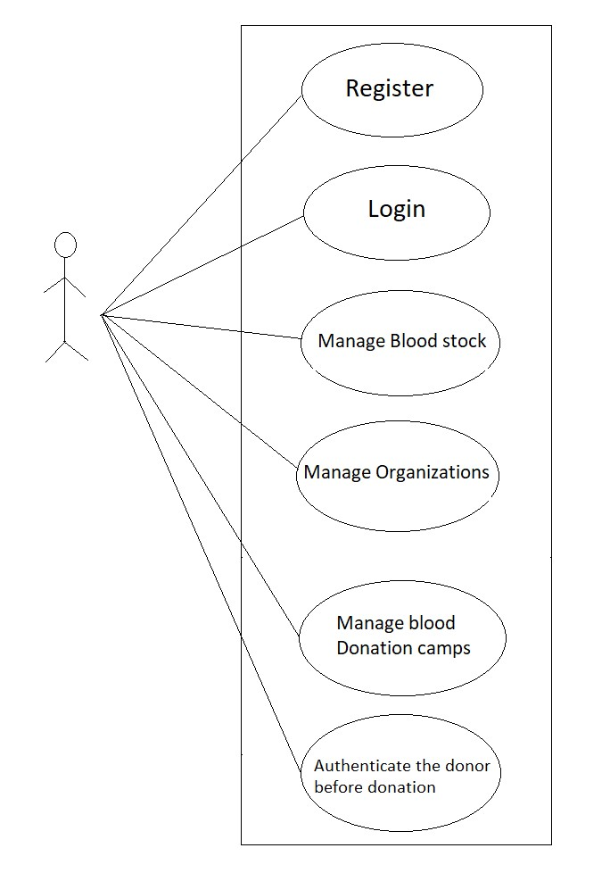

Fig. Use-Case Diagram for Admin

## 5.2 Receiver:

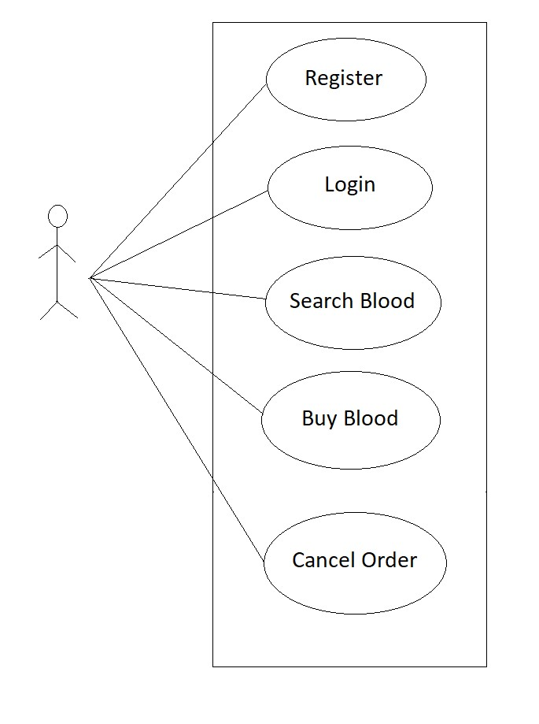

Fig. Use-Case Diagram for Receiver

## 5.2 Donor:

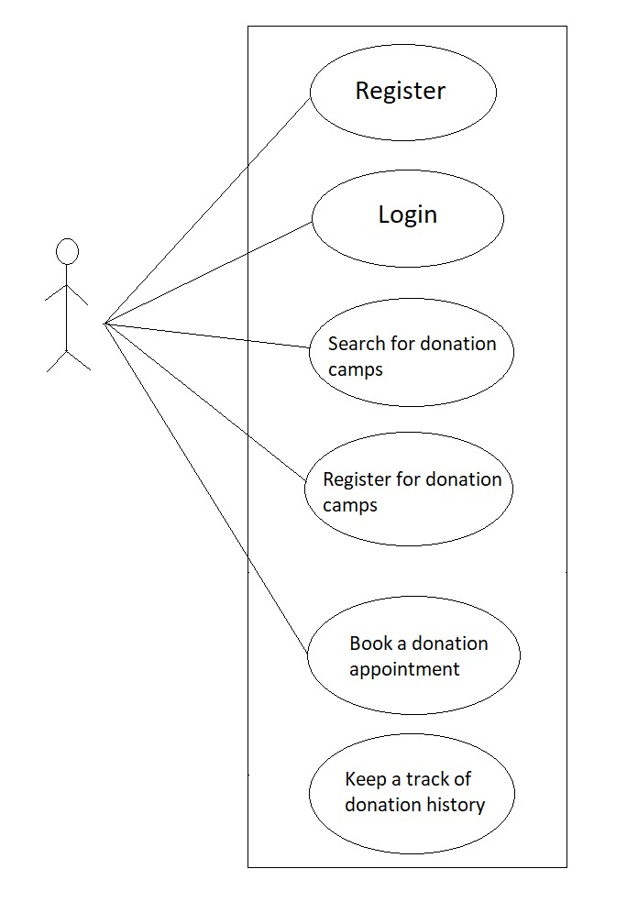Fig. Use-Case Diagram for Receiver

**6. Database Design:**

1. **login table**

|  |  |  |  |  |  |
| --- | --- | --- | --- | --- | --- |
| **login** | | | | | |
| Field | Type | Null | Key | Default | Extra |
|
| id | int | NO | PRI | NULL | auto_increment |
| fullname | varchar(45) | NO |  | NULL |  |
| address | varchar(255) | NO |  | NULL |  |
| city | int | YES |  | NULL |  |
| pincode | varchar(255) | NO |  |  |  |
| username | varchar(45) | NO |  |  |  |
| password | varchar(255) | NO |  |  |  |
| contact | varchar(255) | YES |  |  |  |
| blood_grp | varchar(10) | YES |  |  |  |
| gender | varchar(10) | YES |  |  |  |
| role_id | int | YES | MUL |  |  |

**2] role table**

|  |  |  |  |  |  |
| --- | --- | --- | --- | --- | --- |
| **role** | | | | | |
| Field | Type | Null | Key | Default | Extra |
|
| role_id | int | NO | PRI | NULL |  |
| role_name | varchar(10) | NO |  | NULL |  |

**3] stock table**

|  |  |  |  |  |  |
| --- | --- | --- | --- | --- | --- |
| **stock** | | | | | |
| Field | Type | Null | Key | Default | Extra |
|
| sid | int | NO | PRI | NULL | auto_increment |
| blood_grp | varchar(45) | NO |  | NULL |  |
| qty | int | YES |  | NULL |  |
| desc | varchar(45) | YES |  | NULL |  |
| price | double | YES |  | NULL |  |

**4] camps table**

|  |  |  |  |  |  |
| --- | --- | --- | --- | --- | --- |
| **camps** | | | | | |
| Field | Type | Null | Key | Default | Extra |
|
| cid | int | NO | PRI | NULL | auto_increment |
| location | varchar(255) | YES |  | NULL |  |
| date | date | NO | MUL | NULL |  |
| time | time | NO |  |  |  |

**5] donor history table**

|  |  |  |  |  |  |
| --- | --- | --- | --- | --- | --- |
| **donor_history** | | | | | |
| Field | Type | Null | Key | Default | Extra |
|
| hid | int | NO | PRI | NULL | auto_increment |
| cid | int | YES | MUL | NULL |  |
| donation_date | date | YES |  | NULL |  |
| donor_date | datetime(6) | YES |  | NULL |  |
| did | int | NO |  | NULL |  |
| id | int | YES | MUL | NULL |  |

**6] request table**

|  |  |  |  |  |  |
| --- | --- | --- | --- | --- | --- |
| **request_table** | | | | | |
| Field | Type | Null | Key | Default | Extra |
|
| rid | int | NO | PRI | NULL | auto_increment |
| blood_grp | varchar(200) | NO |  | NULL |  |
| qty | varchar(45) | NO |  | NULL |  |
| date_time | varchar(45) | NO |  | NULL |  |
| id | int | YES | MUL | NULL |  |

**7] payments table**

|  |  |  |  |  |  |
| --- | --- | --- | --- | --- | --- |
| **payments** | | | | | |
| Field | Type | Null | Key | Default | Extra |
|
| pid | int | NO | PRI | NULL | auto_increment |
| address | varchar(255) | NO |  | NULL |  |
| qty | int | NO |  | NULL |  |
| date_time | datetime | NO |  | NULL |  |
| id | int | YES | MUL | NULL |  |

## ER-Diagram:

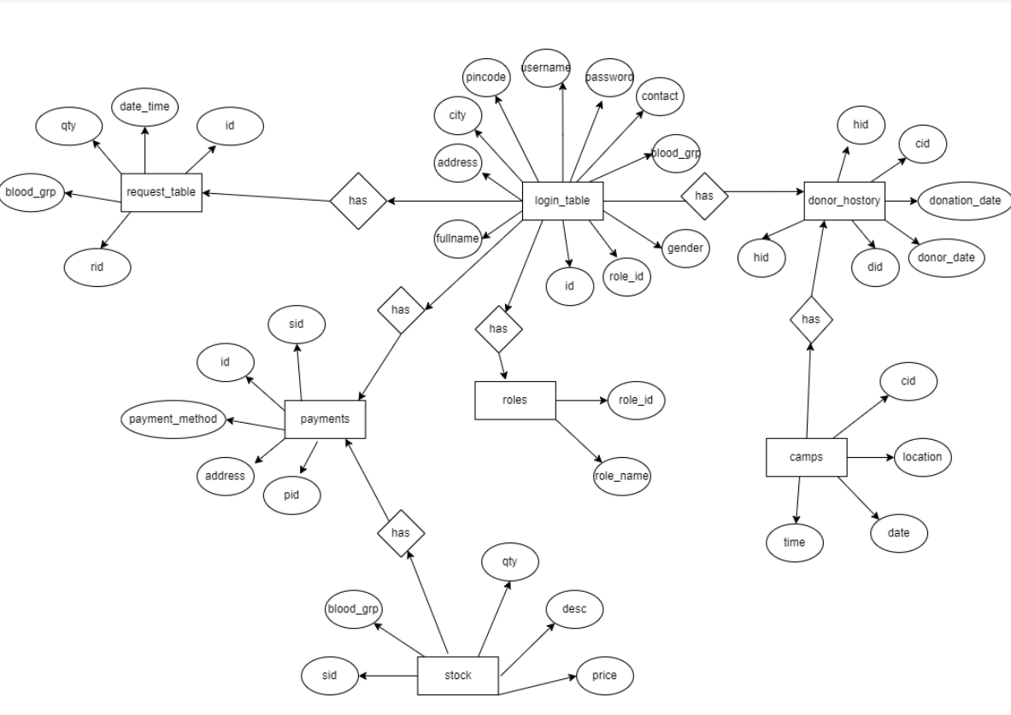

**E-R diagram shows database of LifeStream Blood Bank Management System**

**8. Snapshots:**

**8.1 Home Page:**

Following snapshot shows the Home page

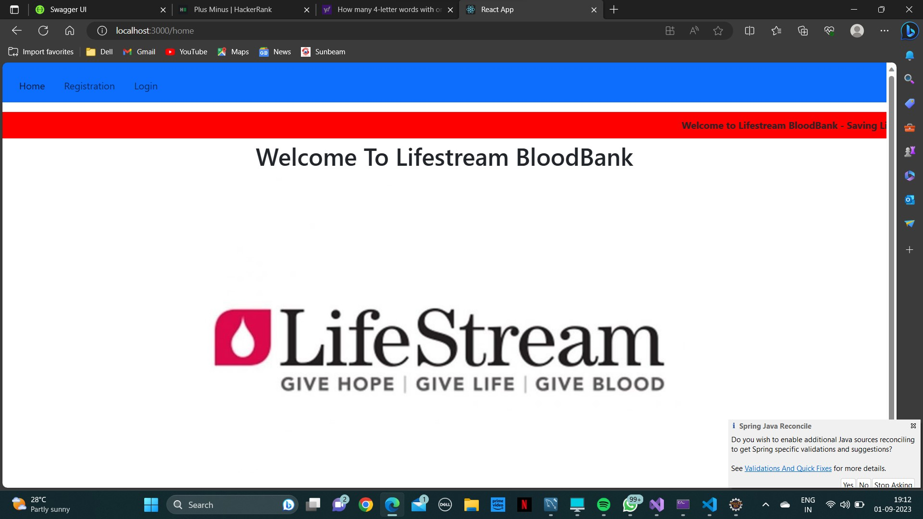

This page contains following controls

* Home
* Registration
* Login Button

This page also contains contact us details.

**8.2 Login Page**

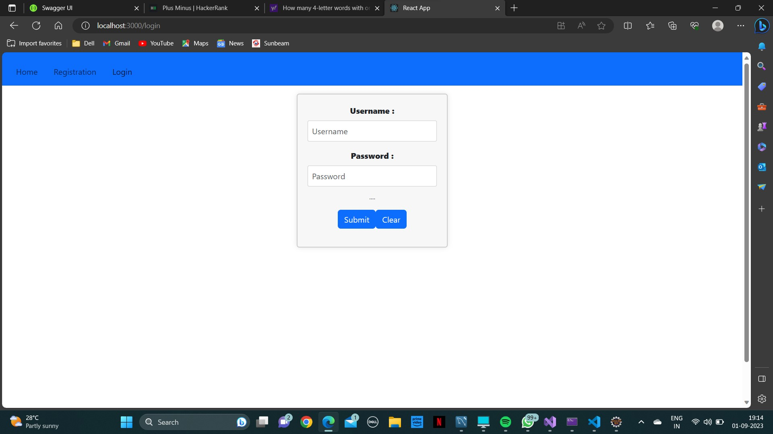

**8.3 Regsitration Page**

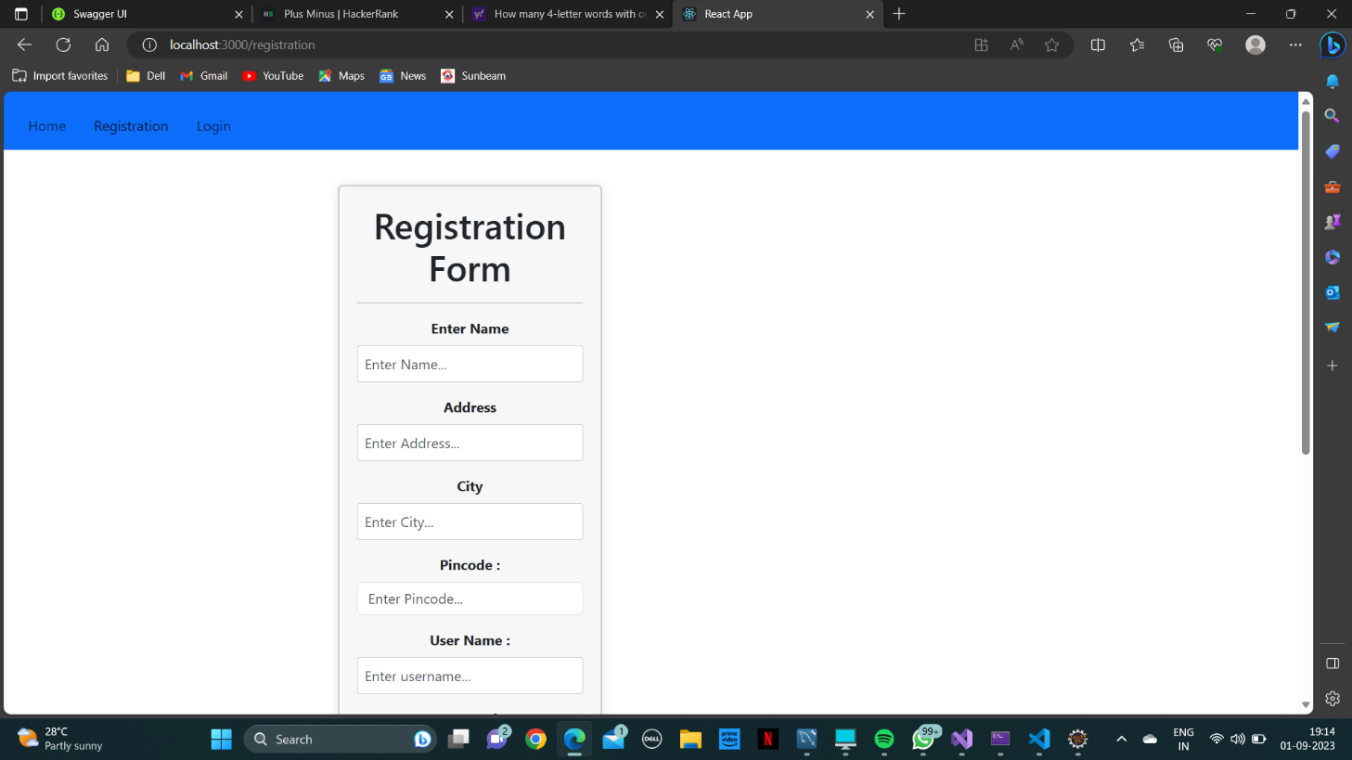

**8.4 Admin Home Page**

**8.4.1 View ,add , delete or update Stock**

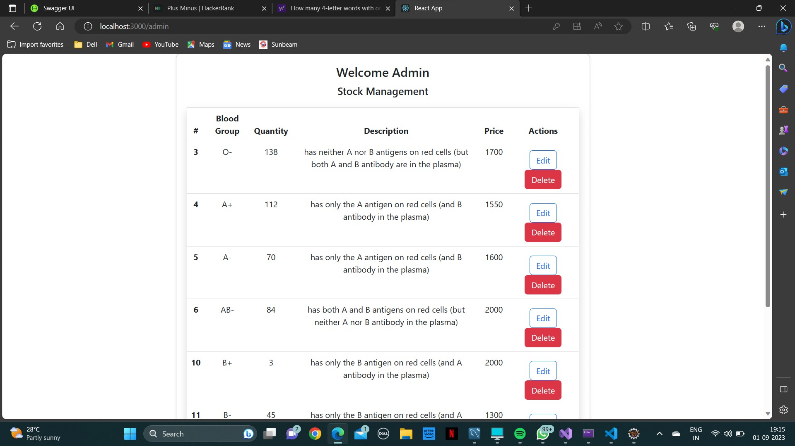

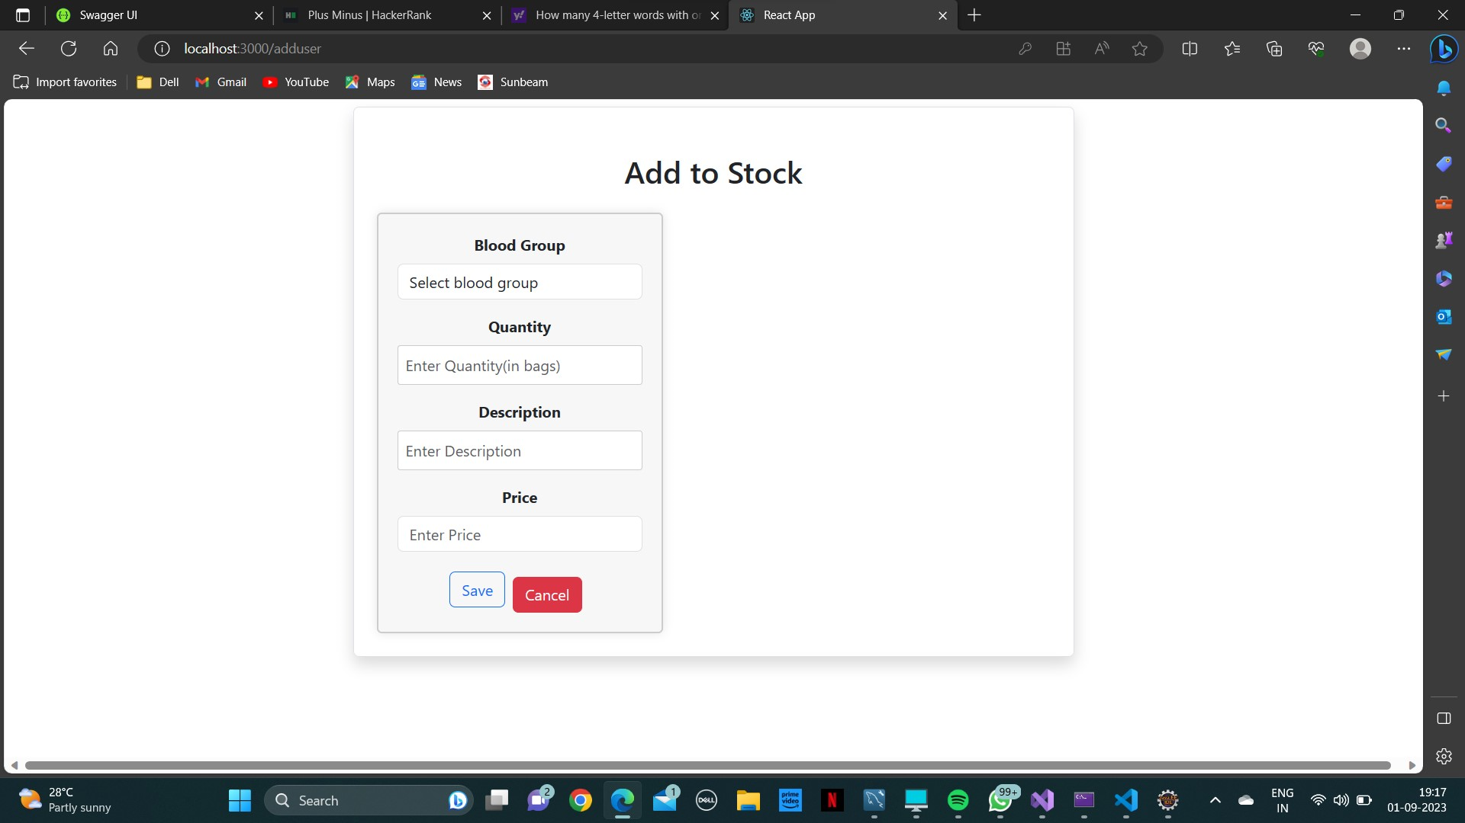

**8.4.1 View ,add , delete or update Camps**

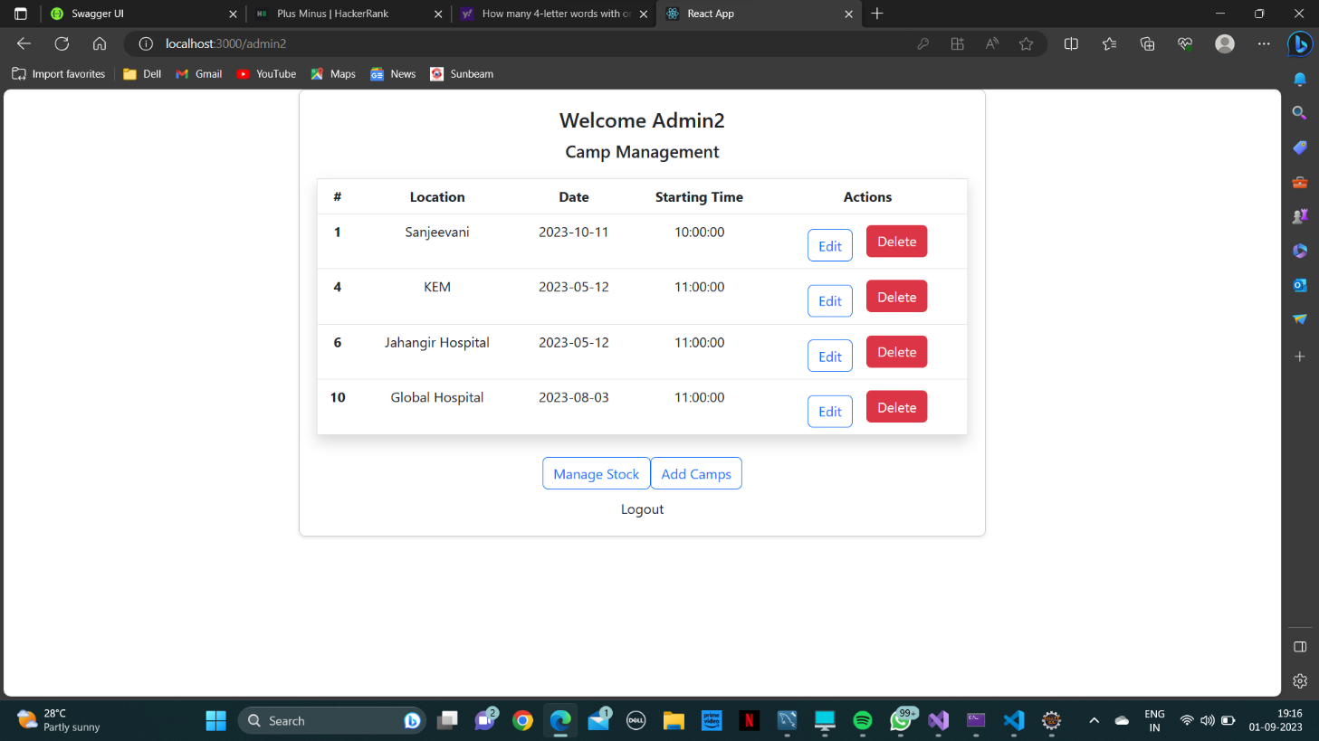

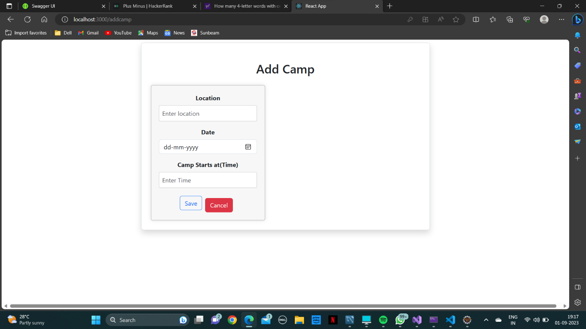

**8.5 Reciever Page**

**8.5.1 Home**

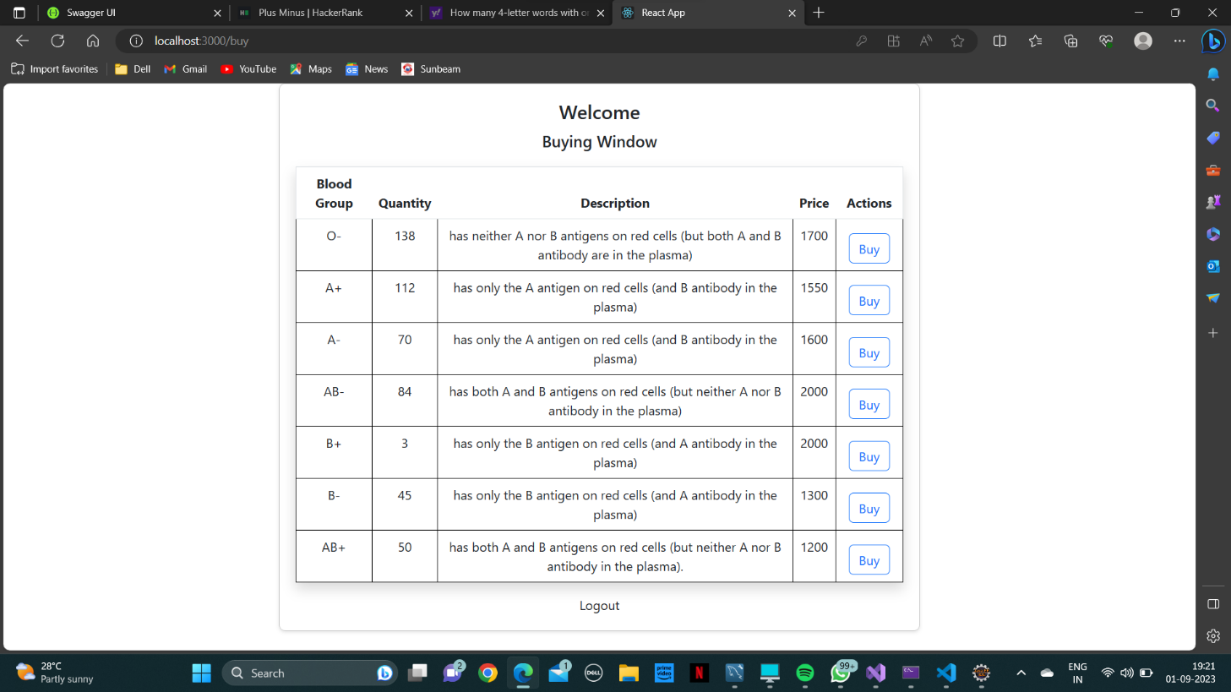

**8.5.2 Buying Window**

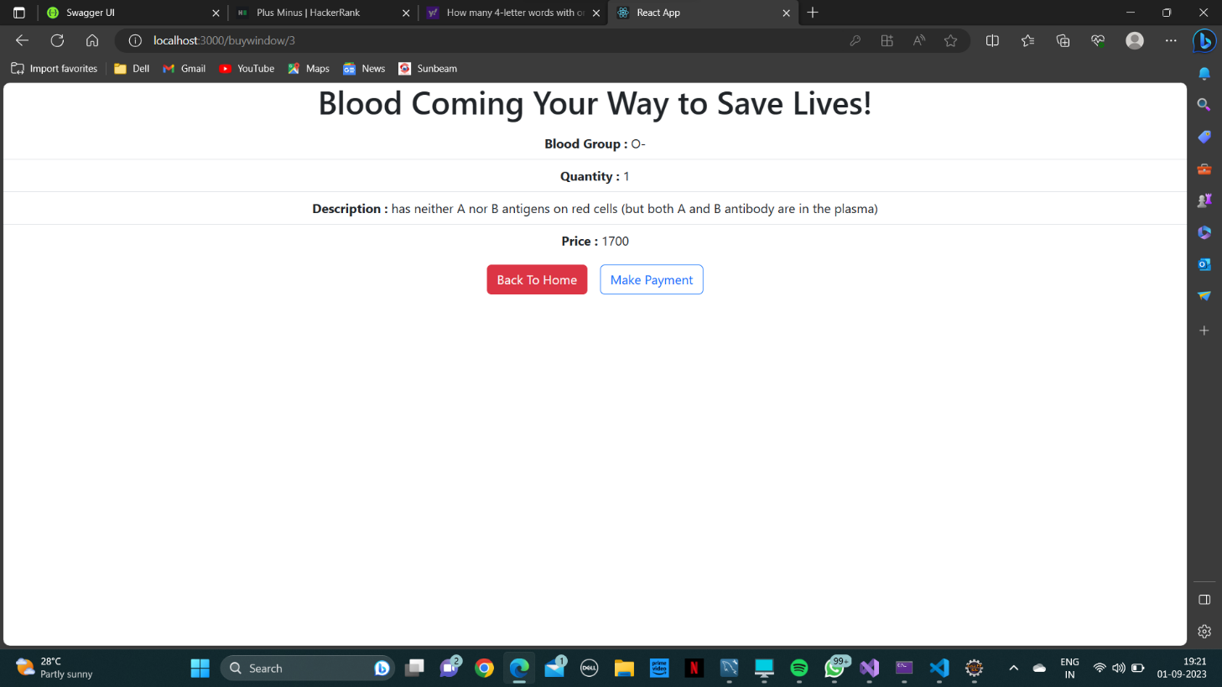

**8.5.3 Payment Status**

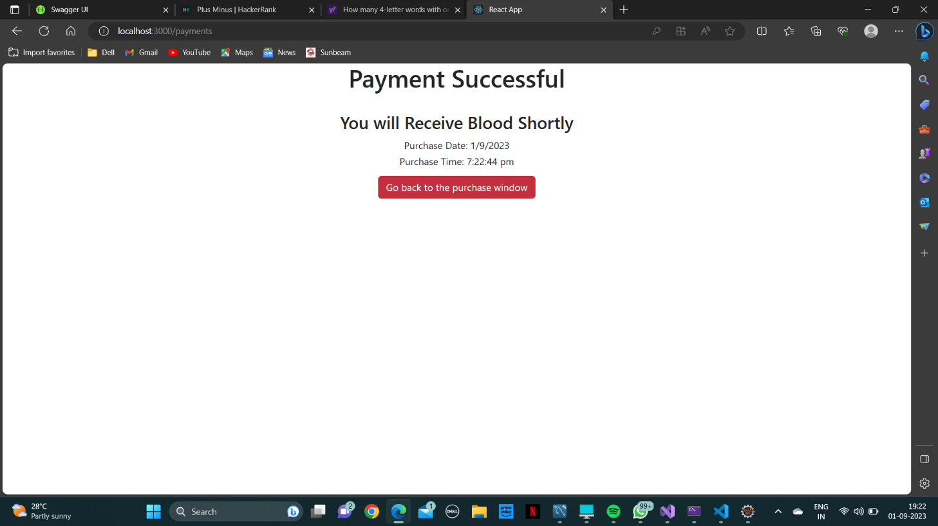

**8.6 Donor Home Page**

**8.6.1 View Camps**

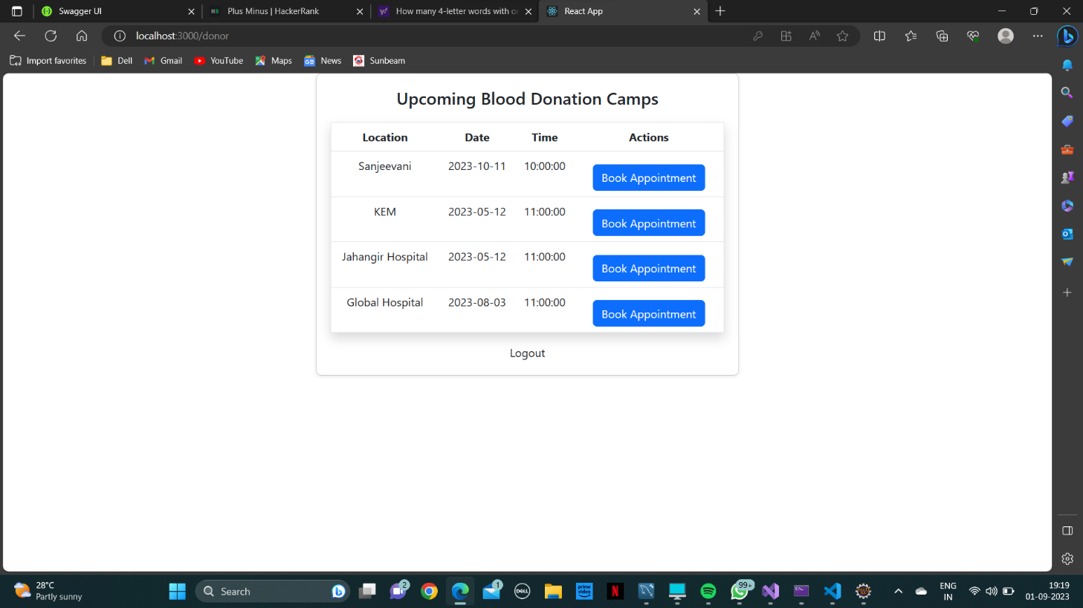

**8.6.2 Date Booking Status**

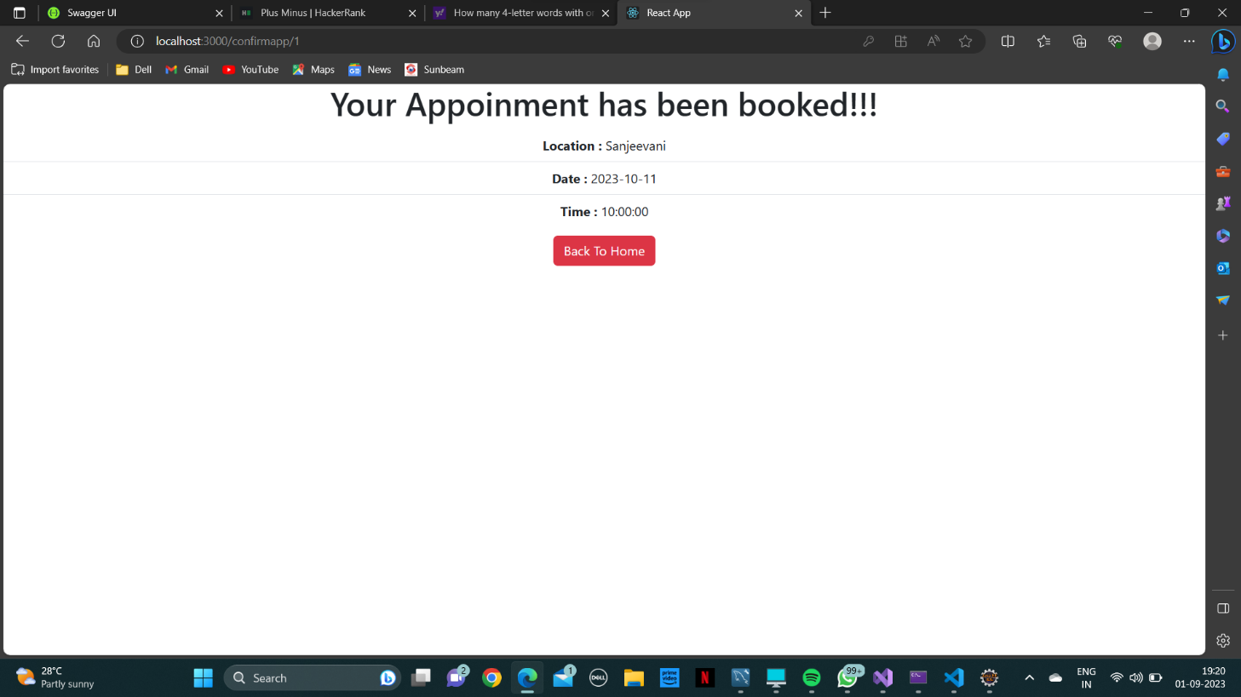

**9. CONCLUSION AND FUTURE SCOPE**

Using this project “Blood Bank Management System” people can search blood group available which they need. They check the details using blood bank management website. The main benefit of this system is the information of available blood group. This will save the time and eventually help to save the life of a person who is in extreme need of the blood in an emergency. This website works 24*7 so user can get information of blood required at any time.